**Task 1*:*** *Scan Your Local Network for Open Ports Objective: Learn to discover open ports on devices in your local network to understand network exposure.*

*Tools: Nmap (free), Wireshark (optional)*

**1.Install Nmap from official website.**

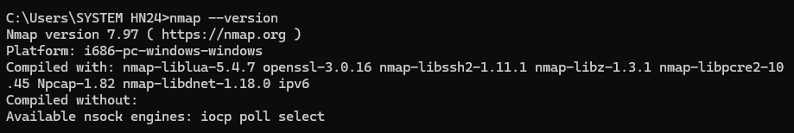

**2.Find your local IP range (e.g., 192.168.1.0/24).**

With the use of ipconfig command

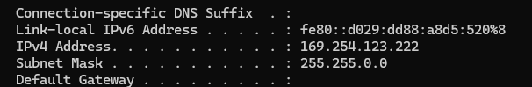

**3.Run: nmap -sS 192.168.1.0/24 to perform TCP SYN scan.**

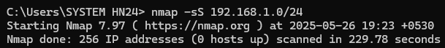

**4.Note down IP addresses and open ports found.**

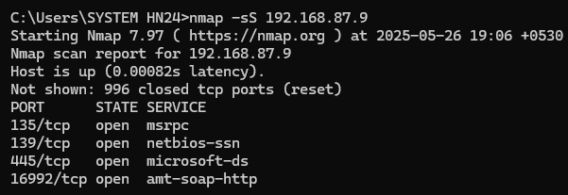

**5.Optionally analyze packet capture with Wireshark.**

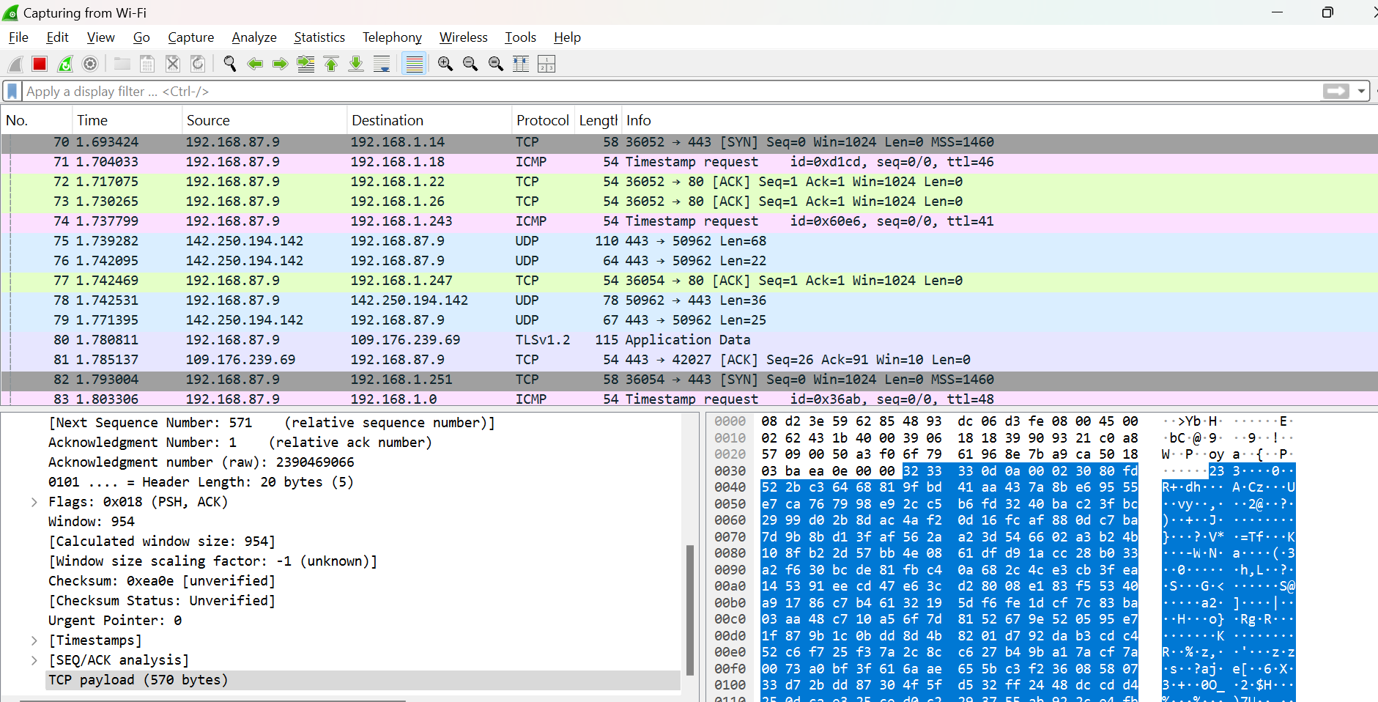

**6.Research common services running on those ports.**

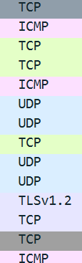

**7.Identify potential security risks from open ports.**

a) Unauthorised access

b) Sensitive Information leakage.

c) Financial/ reputational losses.

d) Data manipulation/ breaches.

e) Malware distribution, cyberattacks.

**8. Saved scan results as a text or HTML file. (word file attached to github repository).**